1. Jo buys a notebook computer which has a 3MHz quad-core central processing unit (CPU).
   1. State the purpose of the CPU. The CPU purpose is to fetch, process and execute.
   2. Describe what is meant by
      1. 3MHz CPU. A 3MHz CPU can process and 3 million cycles per second
      2. Quad-core CPU. A Quad-core CPU mean the CPU has 4 cores
2. A desk-top computer’s memory includes ROM and RAM.  
   Tick **one** box in each row to show whether each of the statements is true for ROM or RAM.  
   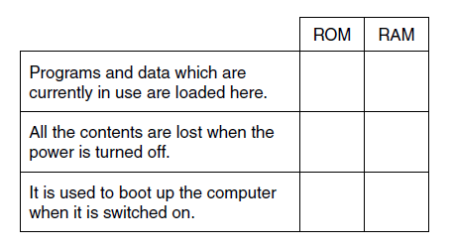
3. A shopping centre uses several remote-controlled CCTV cameras for security. An operator uses a computer to watch, control and record the output of the cameras. State (a) an input, (b) output and (c) storage device which will be needed by the computer. For each, explain the reason why it is needed.
4. The power cable inputs power into the computer
5. The screen outputs a display of pixels
6. The main memory(HDD, SSD, Hybrid) stores all the programs and data.
7. Mina’s computer has 4GB of RAM.
   1. Describe the purpose of RAM in the computer.

RAM Random Access Memory stores the program parts that are in use. A computer that has 4GB RAM can only store that amount.

* 1. The computer also uses virtual memory.
     1. Explain what is meant by virtual memory. Virtual memory is a process where the computer takes parts of programs not in use and moves them onto main memory.
     2. State why virtual memory is needed.

Virtual memory is needed when you are trying to load a program bigger than the RAM can hold. The virtual memory will load parts of the program that you are using into the RAM.

* + 1. Mina upgrades the computer to 6GB of RAM. Explain how this upgrade will affect the performance of the computer.

Having 6GB of RAM would allow you to load programs up to 6GB in size. This would speed up the computer because RAM is a lot faster than virtual memory so you would not have to use as much virtual memory so this would increase the computers performance by having more RAM.

* 1. The following logic circuit can be written as P = (NOT A) AND B  
     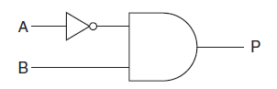  
     Complete the following truth table for the circuit given above.  
     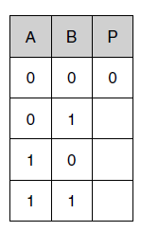
  2. Draw the circuit diagram which will represent the circuit P = NOT (A AND B)

1

0

1



* 1. State what is meant by a storage device, an input device and an output device in a computer system.

Storage device is anything that can store computer information. The USB port is an input. The CPU outputs.

* 1. A secondary school is upgrading its computer equipment. Complete the table below to show whether magnetic, optical or solid state storage is most appropriate for each of the following uses. Give a reason for each case. The first one has been done for you.  
     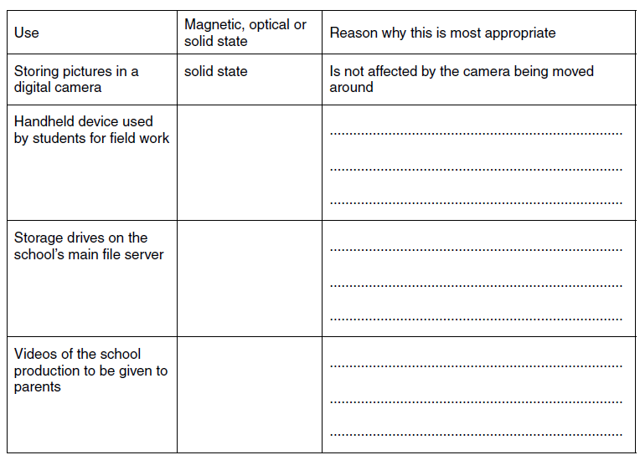

Is portable and can store small amount of data.

Optical

Can store a very large about of computer information.

Magnetic

Is portable and can be moved around easily

Optical

* 1. The secondary school wants the computer systems to be more accessible to students with disabilities. Describe, with examples, input and output devices which are available for students with disabilities. The quality of written communication will be assessed in your answer to this question.

Student with disabilities can use voice recognition software. This can allow the users to talk and not have to use their hands to type on the keyboard. This will mean students who have physical moved problems to use the computers. voice recognition software is a input.

1. Mary’s computer has an 800MHz CPU and 1GB of RAM.
   1. Describe the purpose of the CPU.
   2. Mary wants to upgrade this computer so that she can play the latest games. Explain **two** ways by which the computer can be upgraded to improve its performance.
2. Draw the logic circuit for P = (A OR B) AND C  
   1. The table below contains statements about the functions of the CPU. Tick **one** box in each row to show whether the statement is true or false.  
      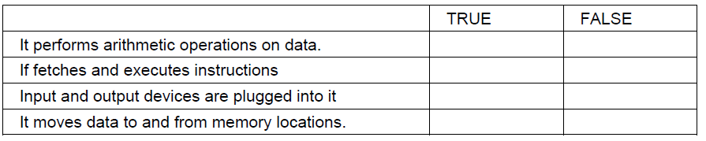
   2. Some CPUs have cache memory.
      1. Describe what is meant by cache memory.
      2. Explain why cache memory is needed.